Cancer Rears Its Ugly Head

October 18, 2014. I’ll never forget that date. We all have one of those. For me it was waking up from a colonoscopy to find a doctor hovering over me. “You have stage 4 colorectal cancer”. I asked if I was going to die. “It doesn’t look good” and then he walked away. The doctors gave me six months to live. I’m going to die? Nobody wants to die. I had a choice to make do I want to live or die? I wanted to live.

They decided to put me in the chemo chair right away to try and reduce the tumors. My cancer originated in my rectum and had aggressively metastasized to my liver and lungs. After four chemo treatments they decided the tumors were too big and decided to operate on me. February 13, 2015, Friday the 13th, and it was going to be my lucky day! I went under the knife for 15 hours while they removed 2/3 of my liver, ¼ of my colon and the large tumor in my rectum. I bled so much during the operation that I almost died. But somehow, I survived. I lost 30 pounds, had a bag coming out of stomach, and spent 2 weeks in the hospital trying to recover. It took me a whole week before I could get out of the hospital bed and take a lap around the ward. It was tough. But so am I. I had to keep fighting.

As I started down the road to recovery, the cancer continued to be aggressive. Doctors put me back on chemo before my strength returned from the surgery. I battled the cancer through 12 rounds of chemo during the summer of 2015. It was hell. You walk into the infusion center and you can see that most patients have lost their will to live – they have lost all HOPE. I think when life turns into non-stop chemo treatments every cancer patient starts to wonder, is it worth living this life of constant pain and struggle? I wanted to come out the other side! I wanted to do it for my kids! I wanted to do it for myself. I’ve got to do it for ALL cancer patients out there. How can we turn the tide and empower cancer patients with a better outlook on life? I wondered, how do we fight for better treatments and better outcomes for those that don’t have a voice? Or for those who don’t know there are other options out there for them than the dreaded chemo chair. The chair saved my life but at the cost of a tremendous amount of physical, emotional and psychological pain. Most cancer patients must feel this way, and they either give up or fight. I wanted to fight.

How Can I Survive? What Can I do to Cure Myself?

There must be something I can do with my technological background and the cancer treatments I have endured. I am a cancer patient, technologist, and patient advocate. I graduated Stanford in 1993 and was lucky enough to jump right into the most exciting time in Silicon Valley, right when Netscape 1.0 browser came out and we were all trying to figure out how to code HTML. I started two successful consulting firms and had the opportunity to build amazing teams that deployed monitoring software for datacenters. Our customers were Apple, Tesla, Novartis, Merck, HP and others. We gained a tremendous amount of experience and it was fun.

Then cancer hit. Now what do I do? Suddenly working in data centers didn’t seem that interesting. I wanted to work on the health care problem. I saw all the technical issues during my cancer fight – data siloed in different EHRs, CDs/DVDs of my scans somewhere else and an industry that STILL likes to use fax machines and emails to get things done. It is archaic, these technical issues must be fixed if I am going to survive my cancer. If I can’t get to my data, then how can my healthcare team possibly treat me if they are working blind? The problem must be solved.

Why not use all the technical skills I learned in the Valley and use them to create an integrated health dashboard for cancer patients and solve the problem? Why not monitor and manage patients in near real time – why do we have to wait 2 weeks for the 10-minute appointment we get with our oncologist. Why not look for treatment options other than chemo and give cancer patients HOPE that there are alternatives to dying from chemo toxicity.

The picture below depicts the standard chemo cycle every cancer patient goes through. Notice how there are gaps in care once treatment is given and you go home? There is minimal monitoring of the patient and almost no data captured on a patient’s condition during a chemo cycle. This is one of the challenges that we cancer patients face. How do we stay out of the ER when chemo toxicity sets in and we have go to the ER? My white blood cell count was so low in January 2018, I had to go to the ER, chemo destroyed my blood counts. Every person that came to visit me in the hospital during that time had to wear a Hazmat suit because my risk of infection was so high. If I caught a virus I would likely die because my body had very low levels of white blood cells to fight off any infection.

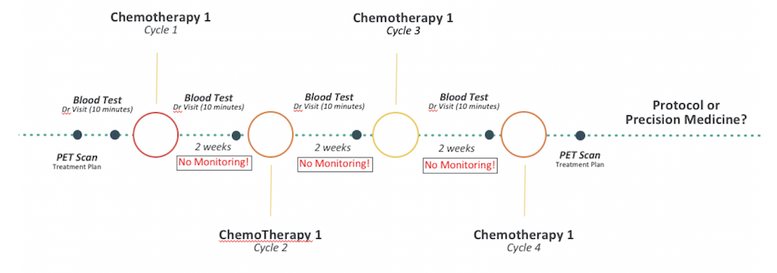
Figure 1: Protocol Treatment Chemo Cycle

The Road from Protocol to Personalized Treatments

Back to the summer of 2015 and my chemo cocktail stories. After 12 rounds of chemo I had developed sores in my mouth and I couldn’t eat. I was DONE with chemo. I didn’t want protocol chemo treatments anymore. I was looking for other options. I was looking for personalized medicine. I didn’t want to see others suffer as I have over the last 4 years. I went through countless chemo treatments, surgeries, procedures, etc. What if we could provide personalized care based on a patient’s own tumor and cure them? This is where cancer treatment is going. The problem today is many providers do not offer personalized care and payers are not yet willing to reimburse expensive genomic tests. Further compounding the problem is that technology hasn’t yet caught up. We are still facing issues with getting our data and dealing with privacy concerns and risk. Why doesn’t a system exist so I can see all my data and work with my oncologist to come up with a personalized plan via dashboards? Not fax machines and emails. Why should I have to login to five different systems to figure out where my data is and how to make sense of it? What if I want to share my data with someone else…why can’t I do that easily? I quickly became depressed when I realized that the integrated health system that I was looking for simply didn’t exist.

So, I figured…why not build it? I decided to use all the technical skills I learned. Instead of monitoring servers and applications in a datacenter, why not monitor chronically ill patients? I started with myself since I didn’t have to worry about privacy concerns. I got my own data and shared it with my own consent. I decided it had to be done, so I quit the consulting company I founded 10 years ago and created Curesoft. The goal was to develop an Integrated Patient Portal that provides not only an integrated health record but also proactive monitoring and management of the patient via intelligent alerts. If I get all my data in one place, then my oncologist should be able to see trends and alerts that give more insight into my cancer and what is happening in my body. Is the treatment working? Why do I have to wait two months for a scan – can’t the data tell us whether its working BEFORE I get scanned? Time is everything to a cancer patient who doesn’t have time. It had become clear to me, this was my life’s mission. At Curesoft we would build a system to help cure my cancer for a start. And, in doing so, if we can provide the same tools/data to other cancer patients, let’s do it! In the end, if we can help save lives and give cancer patients HOPE – that’s what it’s all about.

Breaking Down the Siloes

On the technical side, it’s been traditionally very difficult to integrate with healthcare systems. Large vendors such as EPIC and Cerner have built their products as more of a billing and scheduling system not a health management system. APIs were not an important feature in terms of creating interoperability across siloed EHRs. What we need is an integrated platform where all my data is consolidated and available to me in near real time.

Today it is possible to break down the EHR siloes by leveraging standards that have developed over the past few years. FHIR is one important standard that the community has worked hard to define and now technologists can implement to get data out of EHRs. Utilizing other standards such as oAuth we can now create integrated applications that are data driven based on patient consent. Privacy is a big issue. The patient must be in control of their data and authorize consent to those they would like to share their data with. With FHIR, we can now integrate multiple vendor systems (e.g., EPIC, Cerner, AllScripts, etc.) on behalf of the patient via consent to create an integrated health record. FHIR resources are returned via API calls to a REST endpoint which sits on top of an EHR.

At Curesoft we’ve been able to integrate my data from 5 different EHR systems and consolidate them into one view (see below). I almost cried when I saw all my data from Oct 18, 2014, when I was diagnosed with cancer, through today all in one place, across multiple providers. I finally had my data in one place!

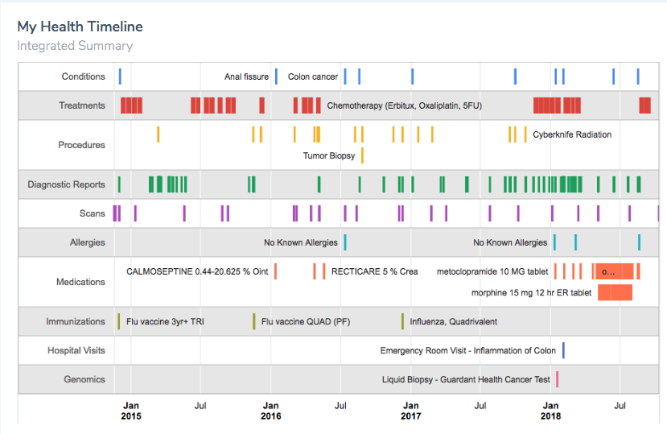
Figure 2: My Integrated Health Record

I now realize what the power of having your own data really means and the potential benefits to all cancer patients (or really any patient):

- More time with my doctor, less time looking for data (manual and across systems)
- Better patient outcome and more personalized experience – shift from protocol to personalized treatments/techniques such as genomics based on my tumor
- Predictive outcomes - utilizing big data and machine learning we can start to predict outcomes
- Stay out of the ER - caregivers can manage patients more proactively through real time dashboards alerts/events. This will keep people out of the ER.
- Unlock siloes and increase efficiencies – take siloed EHRs and consolidate data into an Integrated Health Record (IHR). Save time by having all the data in one place

One important aspect of FHIR is that it is a technical solution to unlock data from different healthcare systems. But what is needed is a business solution on top of FHIR. Without knowing what data you are looking for, it becomes an exercise of getting the data and then trying to figure out what to do with it. The data loses its value unless you harness and focus in on what data is important. In my cancer battle, I’ve focused on critical metrics that my oncologist needed. That way I could filter out the noise and the rest of the data that was not relevant to my cancer.

In my case, I was able to ask my oncologist what she looks for in the data when we meet after a treatment cycle. “Bilirubin, ALP, AST, platelets, and WBCs” she said. “I can tell you whether a treatment is working based on whether these metrics trend up or down over time.” This was the key: if I could harness all of my data around these critical metrics, could I provide a view to my oncologist that would be useful? The answer is yes! Through the Curesoft app we were able to trend my metrics over time and correlate them to the treatments I was going through. With Curesoft, point in time standard ranges aren’t good enough, I need to use my personal ranges over time, across treatments. My oncologist could now take a personalized data driven approach to assess the efficacy of my treatment. All in near real time.
Figure 3: Correlation of Data to Personalized Treatments and their Outcomes

I’ve recently undergone personalized treatment with Panituma, a targeted drug for Colorectal cancer patients. The dashboard above shows the treatments (T), scans (S) and other timeline events captured out of multiple EHRs. The timeline event data is correlated with ALP data which measures liver function. ALP was used as a marker for me as many tumors continue to metastasize in my liver. What you can see on the dashboard is around April 2018. My ALP levels were trending up which is not a good sign. It meant that my liver was processing tumors that were growing. After the targeted treatment was applied around July 2018, the ALP data was trending down. This was a clear sign that my tumors were shrinking and that the treatment was working! After four treatments with the targeted drug, I was scanned and what we had seen in the data was confirmed: the drug worked, and my tumors shrank. This is an excellent example of how big data and correlation back to treatments will help us understand treatment efficacy. It will also allow my oncologist to possibly course correct treatment in the middle of a cycle vs. waiting for the next scan.

Genomics: The Next Frontier

Data doesn’t stop with EHRs. Wearables, APIs and Genomic data are all other types of data that can be pulled in to enhance our integrated health record. Genomics has received a lot of positive press because it is an effort to bring personalized care out of the labs and into the hands of patients. The next wave of personalized treatments will come from genomics and the analysis of each cancer patient’s tumor. Treatments today are largely based on protocol which is typically chemo. But what if we could determine from our own cancerous tumors what mutations exist and what other treatments are available based on the genetic makeup of MY OWN CANCER? Very powerful!

My oncologist and I decided to order a liquid biopsy test to find out if there were any other options for me as we move forward with my ongoing cancer battle. Liquid biopsy tests are done by a blood draw and are preferred by patients vs. standard biopsies which typically involve procedures where you are sedated and spend a day at the hospital. Traditional biopsies are the gold standard today. However, liquid biopsies are quickly gaining ground and traction in terms of accuracy and ease of use (blood test vs. procedure).

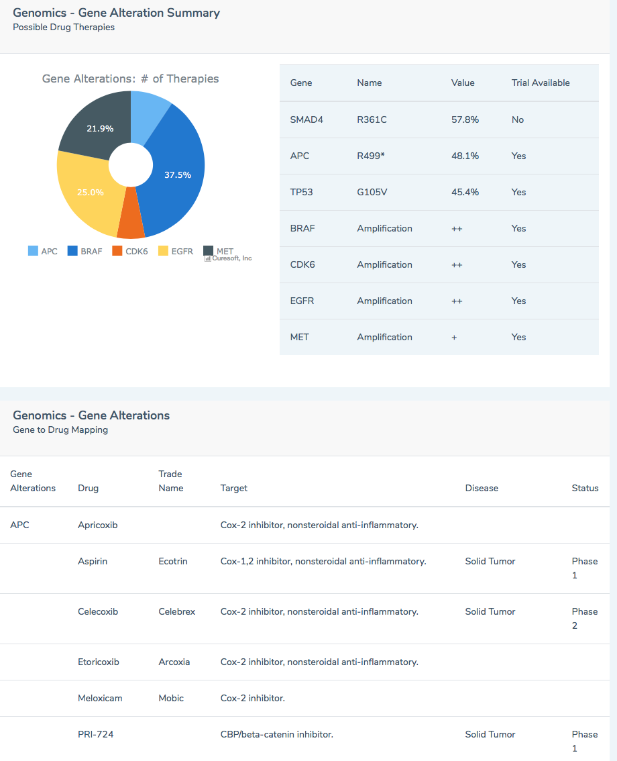

Figure 4: Liquid Biopsy Results – Gene Mutations

We used Guardant Health as the company that provided the testing analysis and results. They looked at over 100+ cancer genes in my tumor and found that seven of them were mutated. With each mutation there was a list of off label drugs that could work on my particular tumor. In addition, the report referenced several clinical trials that I could apply for including name, phone number and location of the trial. This is personalized medicine. These are treatment options given to me based on my tumor results. This gave me tremendous HOPE that I now had an army of options at my disposal and that I didn’t have to live a life of chemo!

Every patient should have access to this kind of personalized data. The challenge today is that payers are not willing to reimburse for these tests until other treatment options, such as chemo, no longer work. I decided to pay out of pocket for my test after the insurance company denied my claim. If it’s going to help me cure my cancer, then I’ll pay. But it sure would be nice to have it covered by the payer. Maybe someday…

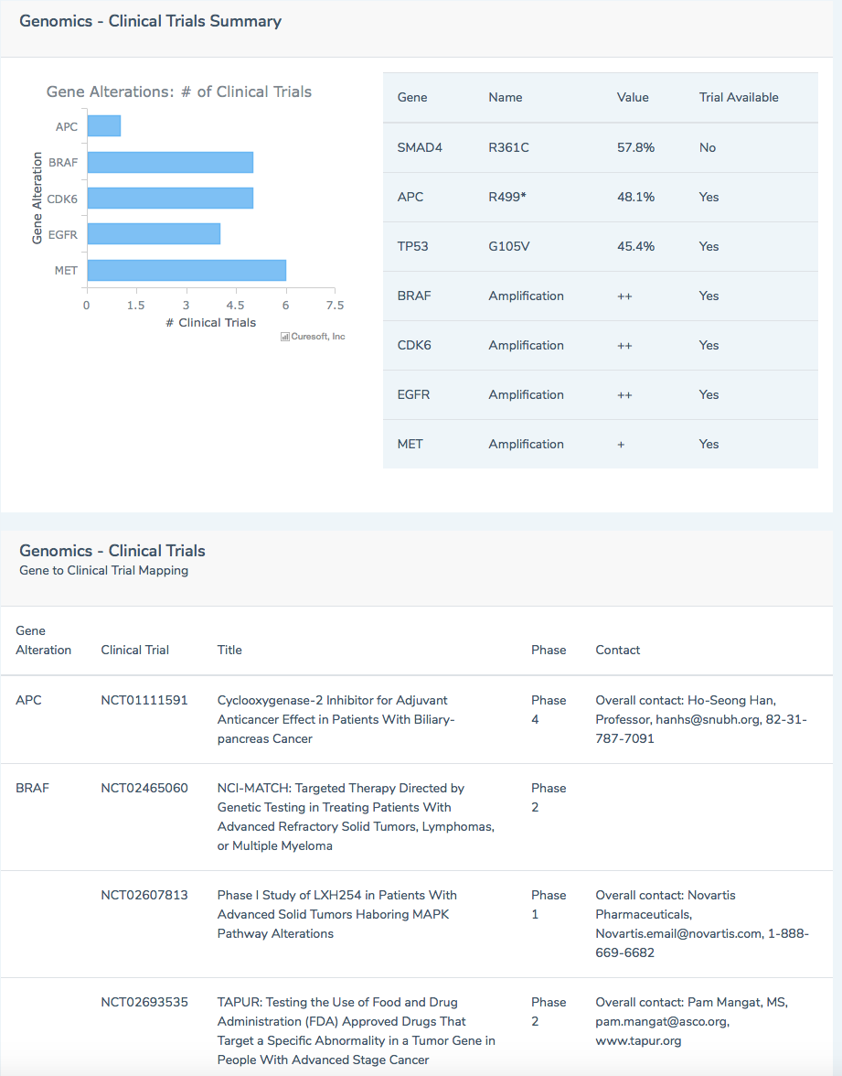

Figure 5: Liquid Biopsy Results – Clinical Trials

My Cancerversary is coming up on October 18th, 2018. It will be my 4th year battling this terrible disease. I consider myself lucky to still be here. They say that 11% of Stage 4 Colorectal cancer patients don’t live more than a year. For some reason I have been able to stay alive through the countless chemo treatments (30+), surgeries, radiation/Cyberknife, and now targeted drugs. And now new exciting treatments are coming out every month. Immunotherapy and CAR-T cell therapy are already showing huge signs of progress and have cured patients in some cases. You must hold on long enough and survive until these treatments are available for your type of cancer. I am confident that the silver bullet will be there soon for all of us.

To my fellow cancer patients out there – continue to fight and never give up! It all starts with owning your data. We have a right to our data so ask for it! Empower yourself with your data. We can beat this! We WILL beat this! It’s only a matter of time. Strength, focus, love, HOPE, that’s all we need.

Cheers,

Michael Morris
mike@curesoft.com

